
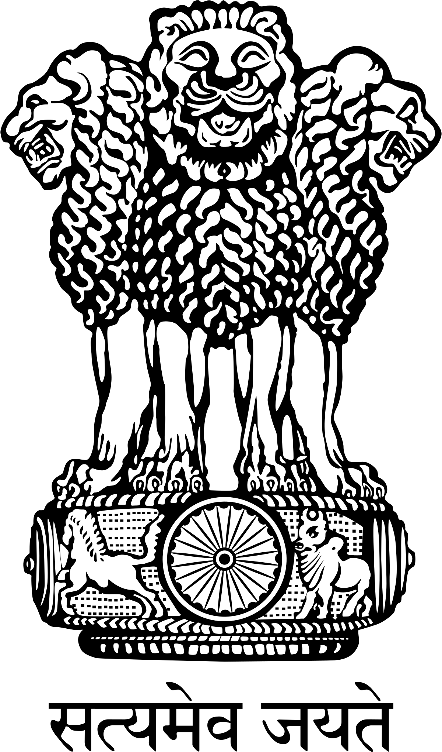




INDUSTRY INTERACTION: DEFENCE CORRIDOR IN UTTAR PRADESH
14 May 2018: 1530 hrs onwards
IIA Bhawan, CF-2, Panki Site-5,Udyog Kunj, Kanpur

Programme

(as on 14 May 2018)

1530 – 1600 hrs Registration of Delegates
1600 – 1605 hrs | Welcome Address by | Shri Sunil Vaish  President – IIA , Partner M/S M/s FALCON Industries, Kanpur.
1605 – 1610 hrs | Video on “Uttar Pradesh: Defence & Aerospace”
1610 – 1620 hrs | Presentation on  “Investment Opportunities in Defence Corridor in Uttar Pradesh” | Ms Khayati Srivastav, Consultant, ENY
1620 – 1630 hrs | Presentation by | Shri. -----------  Department of Defence Production, Ministry of Defence, Govt. of India
1630 – 1640 hrs | Special Address by | Shri Anup Chandra Pandey, IAS  Infrastructure & Industrial Development Commissioner  Government of Uttar Pradesh
1640 – 1655 hrs | Address by the  Chief Guest | Shri Satish Mahana  Hon`ble Minister of Industrial Development  Government of Uttar Pradesh
1655 – 1755 hrs | Industry Interaction Session | Panel Speakers– Dr Anup Chandra Pandey IAS , IIDC U.P, Shri Awanish Kumar Awasthi IAS, CEO, Uttar Pradesh Express Ways Industrial Development Authority ,, Representatives of Army, Nevy, Air Force, DRDO, OFB, HAL, BEML & BEL.
1755 – 1800 hrs | Vote of thanks | Shri S.K.Pandey,  Divisional Chairman, IIA Kanpur Division, MD M/S S.N. Chemicals Pvt. Ltd. Kanpur Dehat.
1800 hrs Onwards | Hi-Tea & Close

*****

