
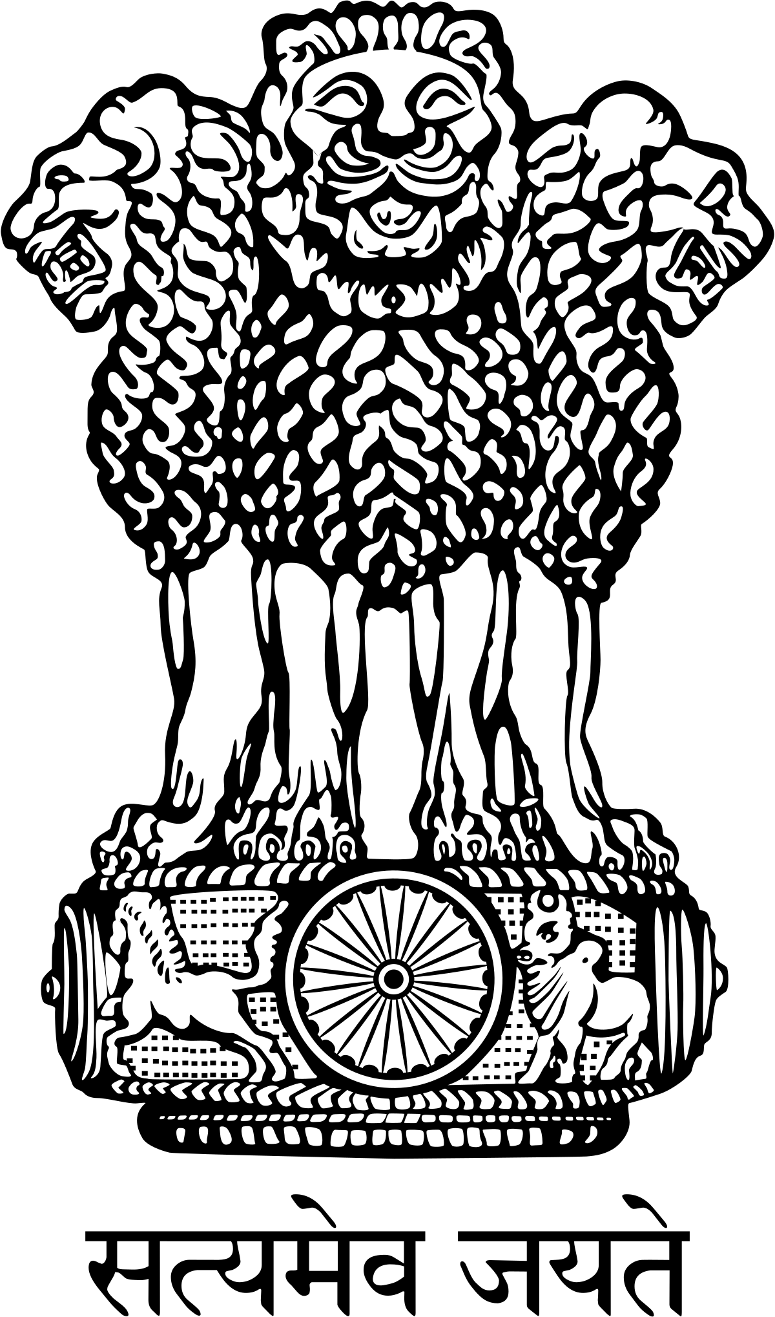




INDUSTRY INTERACTION: DEFENCE CORRIDOR IN UTTAR PRADESH
09 May 2018: 10:30 hrs onwards, IIA Bhawan, Vibhuti Khand,Gomti Nagar, Lucknow

Programme

(as on 09 May 2018)

10.30 – 11.00 AM Registration of Delegates
11.00 AM | Arrival of Hon’ble RRM
11.01 – 11.04 AM | Welcome of Guests on the Dias & Comparing of the programme |  | Shri K.K. Agrawal  General Secretary, IIA
11.04– 11.09 AM | Welcome Address |  | Shri Sunil Vaish  President, IIA
11.10 – 11.14 AM | Key Note Address |  | Lt Gen Subrata Saha, PVSM, UYSM, YSM, VSM** (Retd) Secretary & D.G, SIDM
11.15 – 11.24 AM | Presentation by |  | Shri Rajib Kumar Sen  Economic Advisor, Department of Defence Production, Ministry of Defence, Govt. of India
11.25– 11.27 AM | Video on MAKE- II
11.28 – 11.31 AM | Video on “ Uttar Pradesh : Defence & Aerospace”
11.32 – 11.41 AM | Presentation of “Investment Opportunities in Defence Corridor in Uttar Pradesh” |  | Shri Anup Chandra Pandey, IAS  Infrastructure & Industrial Development Commissioner, Govt. of U.P.
11.42– 11.52 AM | Special Address by |  | Shri Satish Mahana, Hon’ble Minister of Industrial development , Govt. of Uttar Praadesh
11.53 – 12.05 PM | Address by the  Chief Guest |  | Dr. Subhash Ramrao Bhamre  Hon’ble Union Minister of State Ministry of Defence ,Govt. of India
12.06 – 12.09 PM | Thanks giving |  | Shri Chetan Bhalla.  Divisional Chairman IIA, Lucknow Division
12.10 PM | Departure of Hon’ble RRM
12.11- 1.10 PM | Industry Interaction Session | Panel Speakers:  Dr Anup Chandra Pandey IAS , IIDC U.P, Shri Rajib Kumar Sen, Economic Advisor DDP, Shri Awanish Kumar Awasthi IAS, CEO, Uttar Pradesh Express Ways Industrial Development Authority, Dr. Mayank Dwivedi, Sc.G, DRDO, Mr. Rajiv Kumar CEO HAL, Mr. B.K. Gaur, Addl. GM, OEF Kanpur, Mr. Yuvraj A.R., AGM/CMS, BEL, Mr. Sunil Kharad, GM, BEML, AVM B.K. Sood, ACAP (MP), Indian Air Force, Commondore, Valen, PD, Indigenisation , Lt. Colonel Rajesh Sharma, Indian Army, Mr Sachin Agarwal MD PTC, Industries Ltd (Member Industry Representative)
1.11 PM | Lunch & Close

